Process Definition Document (PDD)

*Process Name: HealthCare Daily Appointment*

Table of Contents

**Introduction** **1**

Purpose of the Document 1

Objectives 1

Process Key Contact 1

Minimum Prerequisites for Automation 1

**As-Is Process Description** **2**

Process Overview 2

Applications used in the Process 3

As-Is Process Map 3

**To-Be Process Description** **3**

Detailed Process Map 3

Robot Type 4

Business Exceptions Handling 4

Known Exceptions 4

Unknown Exceptions 4

System Exceptions Handling 4

**Other Observations** **5**

**Additional sources of process documentation** **5**



# Introduction

## Purpose of the Document

The Process Definition Document outlines the business process chosen for automation using UiPath Robotic Process Automation (RPA) technology.

The document describes the sequence of steps performed as part of the business process, the conditions and rules of the process prior to automation and how they are envisioned to work after automating it, partly or entirely. This specifications document serves as a base for developers, providing them with the details required for applying robotic process automation to the selected business process.

## Objectives

The business objectives and benefits expected by the Business Process Owner after automation of the selected business process are:

* Deliver faster processing
* Improve overall performance and reliability
* Reduce redundant activities

## Process Key Contact

The specifications document includes concise and complete requirements of the business process and it is built based on the inputs provided by the process Subject Matter Expert (SME)/ Process Owner.

The Process Owner is expected to review it and provide signoff for accuracy and completion of the steps, context, impact and a set of process exceptions. The details are to be included in the table below.

|  |  |  |  |
| --- | --- | --- | --- |
| Role | Name | Contact Details  (email & phone number) | Notes |
| Process Owner | Mohamed Mohsen | [Mohamed-mohsen96@outlook.com](mailto:Mohamed-mohsen96@outlook.com)  01096699412 |  |
| Business Analyst | Mohamed Mohsen | [Mohamed-mohsen96@outlook.com](mailto:Mohamed-mohsen96@outlook.com)  01096699412 |  |

## Minimum Prerequisites for Automation

|  |  |
| --- | --- |
| Met (Y/N) | Prerequisites |
| Y | A filled in and completed Process Definition Document |
| Y | Closure of any open process questions |
| Y | Environment set up |
| Y | Test Data to support development and testing |
| Y | User access and creation of user accounts (licences, permissions, restriction to create accounts for robots) |

# As-Is Process Description

## Process Overview

General information about the process selected for RPA prior to automation.

|  |  |  |
| --- | --- | --- |
| # | Item | Description |
| 1 | Process Full Name | HealthCare Daily Appointments |
| 2 | Process Area | Health care |
| 3 | Department | Management |
| 4 | Process Short Description  (operation, activity, outcome) | Set patients appointments based on their care type |
| 5 | Role(s) required for performing the process | ACME System 1 User |
| 6 | Process schedule and frequency | Daily |
| 7 | # of items processed /reference period | 15 – 25 Patients |
| 8 | Process execution time | 2 min / Patient |
| 9 | Peak period(s) | No peak period |
| 10 | Transaction Volume During Peak period | N/A |
| 11 | Total # of FTEs supporting this activity | 1 |
| 12 | Expected increase of volume in the next reference period | N/A |
| 13 | Level of exception rate | No expected exceptions |
| 14 | Input data | Patient Data |
| 15 | Output data | Patient appointment and report |

*Add more rows to the table to include relevant data for the automation process. No fields should be left empty. Use “n/a” for the items that don't apply to the selected business process.

## Applications used in the Process

The table includes a comprehensive list of all the applications that are used as part of the process to be automated to perform the given steps in the flow.

|  |  |  |  |  |  |
| --- | --- | --- | --- | --- | --- |
| # | Application Name & Version | System Language | Thin/Thick Client | Environment/ Access Method | Comments |
| 1 | Chrome  87.0.4280.88 | English | Thin | Direct |  |
| 2 | Excel | English | Thin | Direct |  |
| 3 | Word | English | Thin | Direct |  |
| 4 | Outlook | English | Thin |  |  |

*Add more rows to the table to include the complete list of applications.

## As-Is Process Map

**High Level As-Is Process Map:** This chapter depicts the As-Is business process at a High Level to enable developers to have a high-level understanding of the current process.

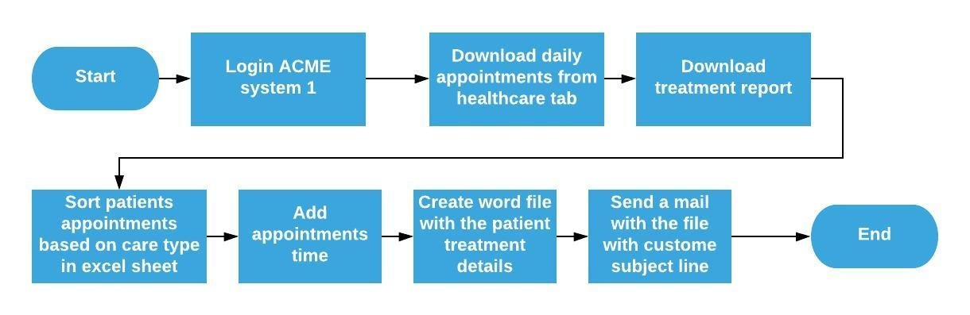

**Detailed Process Map:** This chapter depicts the As-Is business process at a detailed view to enable process owners to document their process

|  |  |  |  |
| --- | --- | --- | --- |
| # | Step Action/Description | Screenshot | Remarks |
| 1 | Open the ACME System 1  Web Application | N/A | **https://acme-test.uipath.com/** |
| 2 | Log in to System 1 |  | Enter username and password  Exception:  Invalid username or password |
| 3 | Access the medical Daily appointments by clicking Download Daily Appointments from the Health Care tab |  |  |
| 4 | Download each appointment from “Today”, in folder named “Appointments\Patients\dd-MM-YYYY” |  | Do this by clicking on the file name in the second column for each patient |
| 5 | Add each appointment in the new excel file ”MM/DD/YYYY_Appointments” according to the care type (Urgent first then Emergency and routine lastly) |  |  |
| 6 | Add appointment column with the time of each appointment (Every appointment is 15 min starting from 12pm) |  |  |
| 7 | Create word file “PatientName_PatientID” for each patient with his treatment details in folder “Patients reports” |  |  |
| 9 | Send mail to yourself with the patient report as pdf and customed subject line |  |  |

# To-Be Process Description

## Detailed Process Map

**High Level To-Be Process Map:** This chapter depicts the To-Be automation process at a High Level to enable developers/COE to have a high-level understanding of the to be developed process.

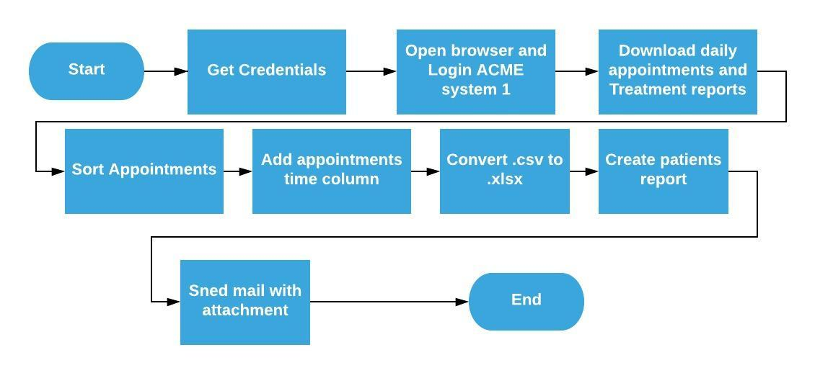

**Detailed Process Map:** This chapter depicts the To-Be automation process at a detailed view to enable developers/COE to see the workflows involved in the RPA solution

|  |  |  |  |  |  |
| --- | --- | --- | --- | --- | --- |
| **Workflow Name** | **Description** | **Pre-conditions** | **Post-actions** | **Arguments** | **Notes** |
| GetCredentials | Get ACME system credentials from orchestrator | Credentials added in orchestrator | N/A | out_Password-String  out_Username-String | Add asset  “User credentials” that contains log in username and password |
| OpenApps | Opens all used apps in process. | list of used apps defined | Apps opened | out_ACME_URL-String  out_Apps-String[] | Add asset  “ACMELink” |
| LogInACME | Logs into the ACME test site and ensures the login was successful. | Chrome browser open to the ACME login page | Logged into ACME - on homepage | in_Username-String  in_Password-String  in_ACME_URL-String | Throw BRE  if the page  didn’t load  or the login  credentials  didn’t  work. |
| DownloadAppointments | Download each appointment file from the table, in the download directory then move it to a folder with today's date in the patient folders in the appointment folder in the project folder directory that has been extracted from orchestrator. | Chrome browser open to the ACME homepage | patients appointment excel files downloaded in the specific directory | in_ACME_URL-String  out_TodayAppointments-String  out_ProjectFolderLocation-String | Add asset  “ProjectFolder” that contains the directory of the project folder location |
| DownloadTreatmentReport | Download treatment report and save it in the project directory in "Reports" folder. | Chrome browser open to the ACME Dashboard | Treatment report downloaded in the specified directory | in_ProjectFolderLocation-String  in_ACME_URL-String |  |
| SortAppointments | Sort all the patients appointments in one excel file according to the care type they need and update the social number of every patient to a queue. | Downloaded appointments files | Today's Excel file with sorted appointments | in_TodayAppointments-String  out_TodayAppointmentsSheet-String  in_ProjectFolderLocation-String | Appointments must be sorted depending on the care type.  1-Urgent  2-Emergency  3-Routine |
| AppointmentTime | Give appointment time for each patient according to the clinic start work time and the duration for each appointment. | Today's Excel file with the sorted appointments | Additional column in the excel file with the appointments time. | in_TodayAppointmentsSheet-String | Add assets  “ClinicWorkTime” that is the starting time of the clinic ex,12:00 PM  “AppointmentDuration” that is the duration of each appointment |
| TimeManipulation | In this workflow the robot assign the start and end of each appointment, make sure that appointments follow the duration time and changing of time. | Clinic starting time | Appoitnment time | in_AppointmentDuration-int32  in_DayTime-String  out_StartAppointment-String  out_EndAppointment-String |  |
| Convert(.csv)To(.xlsx) | The downloaded treatment report file is of type .csv. In this workflow we will convert it's type to .xlsx, then delete the .csv file. | Treatment Report.csv downloaded in reports directory | Treatment Report.xlsx in reports directory | in_ProjectFolder-String |  |
| PatientReport | In this process we create a reports folder with the date of the reports "\AppointmentsDate_reports" in the project directory in Reports folder. Then for each patient in queue we add his data in copied word file of the standard patients report template. Lastly, we send the pdf file to SendReport workflow and delete patient word file, keeping the pdf file. | Updated queue with patients social number. | PDF files of each patient data. | in_ProjectFolder-String  in_TodayAppointmentsSheet-String |  |
| SendReport | Here we send a mail with subject line of the patient full name, and attachment of his PDF report file to your mail that is extracted from orchestrator asset. | Patient report PDF file. | Mail sent to your email with the patient file. | in_PatientReport-String | Add asset ”OutlookMail” which is an outlook email |
| KillAllApps | This work flow takes the apps that used in the process and kills them all. | Argument with all the apps used defined | Apps killed, process ended. | in_Apps-String[] |  |

## Robot Type

|  |  |  |  |  |
| --- | --- | --- | --- | --- |
| # | Attended | Unattended | Trigger | Comments |
| 1 | N/A | Yes | By the user when needs it | Use asset to gets user’s data like login credentials |

## Business Exceptions Handling

The Business Process Owner and Business Analysts are expected to document below all the business exceptions identified in the automation process. These can be classified as:

### Known Exceptions

The table below reflects all the business process exceptions encountered during the process evaluation and documentation. These are known exceptions that occurred before. For each of these exceptions, define a corresponding expected action that the robot should complete if it encounters the exception.

|  |  |  |  |  |
| --- | --- | --- | --- | --- |
| BE # | Exception Name | Step | Parameters | Action to be Taken |
| 1 | Incorrect Email or  Password/ACME site  down | 2 | Check for Log Out  button | Log with Error level  and Throw BRE |

### Unknown Exceptions

For all other unanticipated or unknown business (process) exceptions, the robot should:

* Log with Error level and Kill any open applications (Chrome)

## System Exceptions Handling

A comprehensive list of all errors, warnings or notifications should be consolidated here with the description and action to be taken, for each, by the robot.

Errors identified in the automation process can be classified as:

|  |  |  |  |  |
| --- | --- | --- | --- | --- |
| SE # | Exception Name | Step | Parameters | Action to be Taken |
| 1 | Excel Exception | Any | Excel file is opened while working on it | Close excel application |
| 2 | Chrome page not load | Any | Pages did not load | Open application with the url |
| 3 | Queue Transaction | 7 | Queue item transaction failed | Retry |

For all the other unanticipated or unknown system exceptions, send an email to [**mohamed-mohsen96@outlook.com**](mailto:mohamed-mohsen96@outlook.com)and attach a screenshot of the error message.

# Other Observations

Include below any other relevant observations you consider needed to be documented here.

* N/A

# Additional sources of process documentation

* N/A